**Window Object with Document Object**

**Window Object:**

The window object is the topmost object of the DOM hierarchy and represents the browser window. The window object is supported by all browsers. All global JavaScript objects, functions, and variables automatically become members of the window object. The window is the first thing that gets loaded into the browser. This window object has the majority of the properties like document, location, length, innerWidth, innerHeight, name, if it has been closed, its parents, and more. Whenever a window appears on the screen to display the contents of the document, the window object is created.

The window object represents the current browsing context. It holds things like window.location, window.history, window.screen, window.status, or window.document . Each browser tab has its own top-level window object. Each of these windows gets its own separate global object. window.window always refers to window, but window.parent and window.top might refer to enclosing windows, giving access to other execution contexts**.**

**Syntax:**

window.property_name;

**Document Object:**

The document object represents a web page that is loaded in the browser. The document object is the root node of the HTML document. By accessing the document object, we can access the element in the HTML page. With the help of document objects, we can add dynamic content to our web page. The document object is a property of the window object or It is the direct child of the window object. The document actually gets loaded inside the window object and has properties available to it like title, URL, cookie, etc. The document object can be accessed with a **window.document**or just**document.**

**Syntax:**

document.property_name;

**Examples**

**let url = window.document.URL;**

**let url = document.URL;**

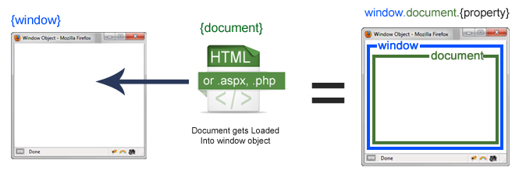

Fig : Javascript Window Object with Document Loaded

**Difference between document and window:**

|  |  |
| --- | --- |
| **Document** | **Window** |
| It represents any HTML document or web page that is loaded in the browser. | It represents a browser window or frame that displays the contents of the webpage. |
| It is loaded inside the window. | It is the very first object that is loaded in the browser. |
| It is the object of window property. | It is the object of the browser. |
| All the tags, elements with attributes in HTML are part of the document. | Global objects, functions, and variables of JavaScript are members of the window object. |
| We can access the document from a window using the window. document | We can access the window from the window only. i.e. window.window |
| The document is part of BOM (browser object model) and dom (Document object model) | The window is part of BOM, not DOM. |
| Properties of document objects such as title, body, cookies, etc can also be accessed by a window like this window. document.title | Properties of the window object cannot be accessed by the document object. |
| **Syntax**:  document.propertyname; | **Syntax:**  window.propertyname; |
| **Example:**  document.title :  will return the title of the document | **Example:**  window.innerHeight : will return the height of the content area of the browser |